**Master Functional Document**

|  |  |
| --- | --- |
| **Application** | NGERP - Centra |
| **Service Bundle** | Master Management |
| **Service Request** | User |

**Description :**

User master is used to create the user which is used for login. The user has access to the application defined in the Role Master in which the user is mapped.

**Workflow Process :**

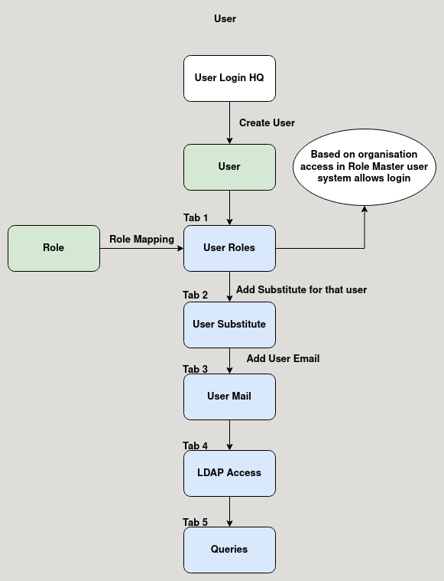

**Business Rules :**

* User Master can be only created in HQ.
* The user master is used to create user for the application which is used to login into the application.
* After creating the user the user is mapped to a role in the User Role tab.
* The user has all the access defined in the user Role master.
* There are five tabs in user master:
  + User Role
  + User Substitute
  + User Mail
  + LDAP Access
  + Queries
* **User Role:**

This tab is used to map the role to the user from role master.

* **User Substitute:**

Substitute can be maped the user in this tab.

* **User Mail:**

User Mail can be added in this tab.